**VISVESVARAYATECHNOLOGICALUNIVERSITY**

**“JnanaSangama”, Belgaum -590014, Karnataka.**

## LAB RECORD

**Computer Network Lab (23CS5PCCON)**

***Submitted by***

**Devashish Baluni (1BM22CS084)**

***in partial fulfillment for the award of the degree of***

**BACHELOROFENGINEERING**

***in***

**COMPUTER SCIENCE AND ENGINEERING**



# B.M.S. COLLEGE OF ENGINEERING

**(Autonomous Institution under VTU)**

# BENGALURU-560019

**Academic Year 2024-25 (odd)**

B.M.S. College of Engineering

**Bull Temple Road, Bangalore 560019**

(Affiliated To Visvesvaraya Technological University, Belgaum)

**Department of Computer Science and Engineering**



**CERTIFICATE**

This is to certify that the Lab work entitled “ Computer Network (23CS5PCCON)” carried out by **Devashish Baluni (1BM22CS084)** who is a bonafide student of **B.M.S. College of Engineering.** It is in partial fulfilment for the award of **Bachelor of Engineering in Computer Science and Engineering** of the Visvesvaraya Technological University, Belgaum. The Lab report has been approved as it satisfies the academic requirements of the above-mentioned subject and the work prescribed for the said degree.

Dr. Kavitha Sooda Professor & HOD

Department of CSE, BMSCE

Spoorthi D M

Assistant Professor Department of CSE, BMSCE

## Index

|  |  |  |  |
| --- | --- | --- | --- |
| **Sl.**  **No.** | **Date** | **Experiment Title** | **Page No.** |
| 1 | 09-10-24 | Create a topology and simulate sending a simple PDU from source to destination using hub and switch as connecting devices and demonstrate ping messages. | 4-8 |
| 2 | 09-10-24 | Configure IP address to routers in packet tracer. Explore the following messages: ping responses, destination unreachable, request timed out, reply. | 9-11 |
| 3 | 16-10-24 | Configure default route, static route to the Router (Part 1). | 12-14 |
| 4 | 23-10-24 | Configure default route, static route to the Router (Part 2). | 15-17 |
| 5 | 13-11-24 | Configure DHCP within a LAN and outside LAN. | 18-22 |
| 6 | 20-11-24 | Configure RIP routing Protocol in Routers . | 23-25 |
| 7 | 20-11-24 | Demonstrate the TTL/ Life of a Packet. | 26-28 |
| 8 | 27-11-24 | Configure OSPF routing protocol. | 29-31 |
| 9 | 18-12-24 | Configure Web Server, DNS within a LAN. | 32-33 |
| 10 | 18-12-24 | To construct a simple LAN and understand the concept and operation of Address Resolution Protocol (ARP). | 34-36 |
| 11 | 18-12-24 | To understand the operation of TELNET by accessing the router in the server room from a PC in the IT office. | 37-39 |
| 12 | 18-12-24 | To construct a VLAN and make the PC’s communicate among a VLAN. | 40-43 |
| 13 | 18-12-24 | To construct a WLAN and make the nodes communicate wirelessly. | 44-46 |
| 14 | 18-12-24 | Write a program for error detecting code using CRC-CCITT (16-bits). | 47-48 |
| 15 | 18-12-24 | Write a program for congestion control using Leaky bucket algorithm. | 49-50 |

|  |  |  |  |
| --- | --- | --- | --- |
| 16 | 18-12-24 | Using TCP/IP sockets, write a client-server program to make the client send the file name and the server to send back the contents of the requested file if present. | 51-52 |
| 17 | 18-12-24 | Using UDP sockets, write a client-server program to make client sending the file name and the server to send back the contents of the requested file if present. | 53-54 |

Github Link: https://github.com/ShubhamMaloo00/1BM22CS343_ShubhamMaloo_C

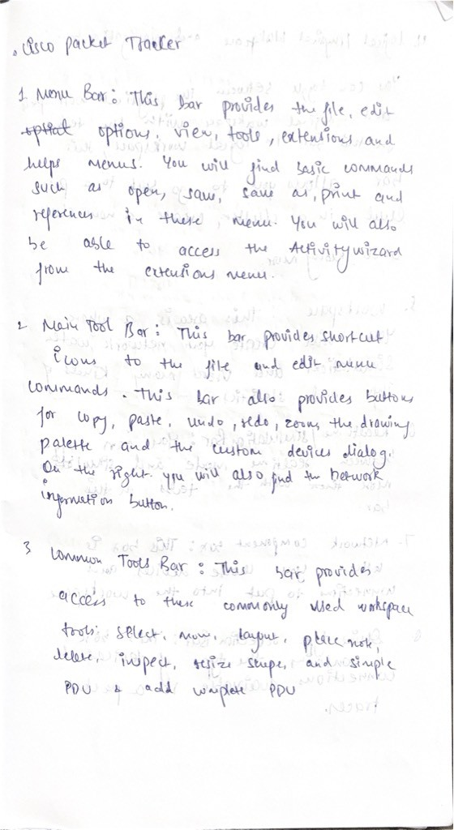

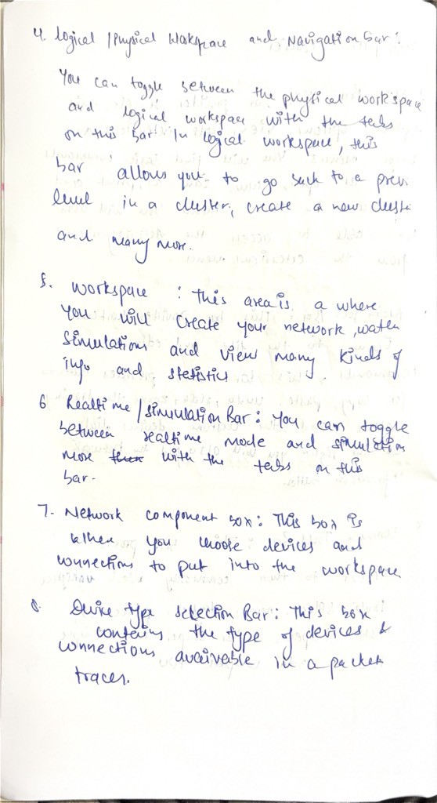

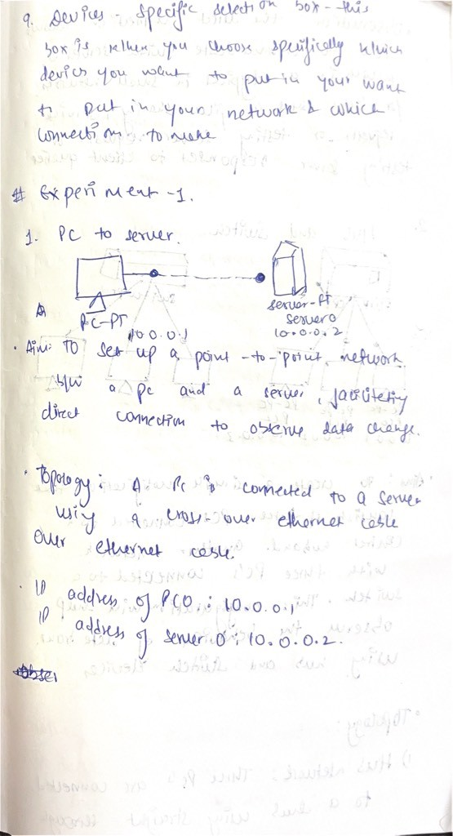

cam scan

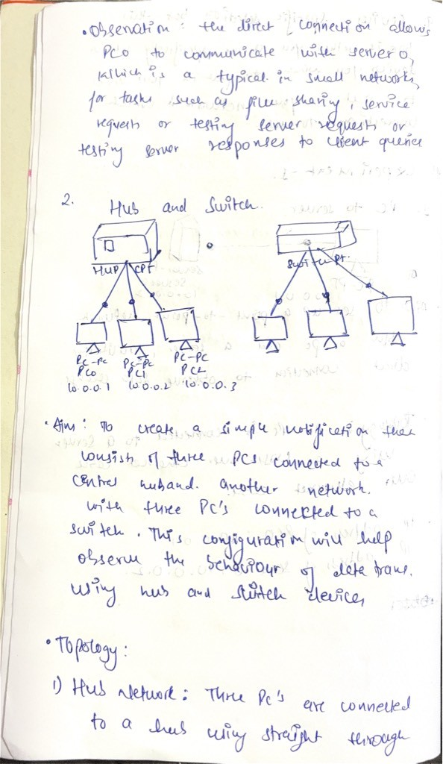

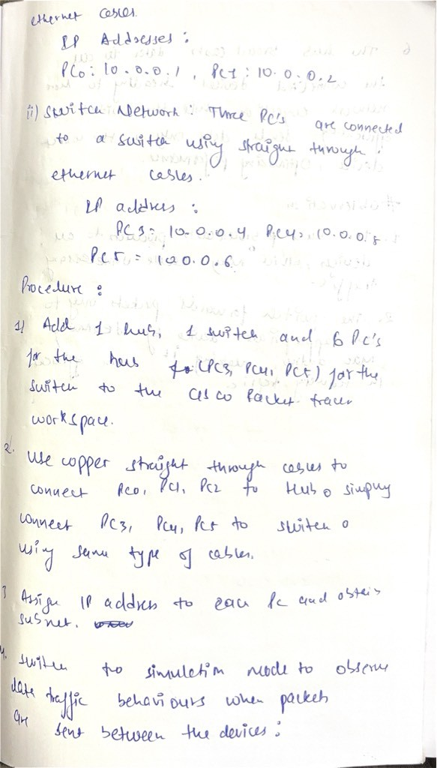

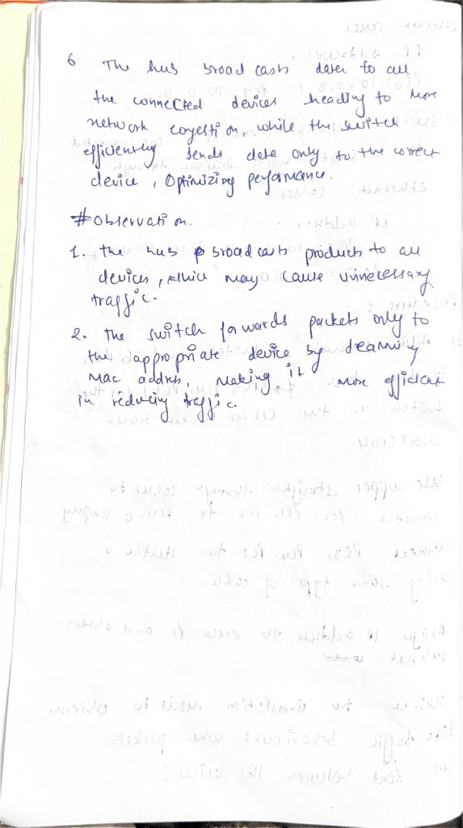

scan

